

Nuclear Instrumentation and Measurement
0407204, Fall 2024-25
Midterm Exam
Instructor: | Dr. Muhammad Zubair
CRN: | 11582
Section: | 11
Date and Time: | October 14, 2024, 2:00– 3:00 PM
Place: | M10-004

Student Name: |  | ID:

Grading
Q1 | Q2 | Q3 | Total
10 | 10 | 10 | 30

Useful Data:
1 amu=1.6605x10⁻²⁷ kg, 1 amu ≡ 931.48 MeV, 1 eV = 1.6022 × 10⁻¹⁹ J , m_{e} = 0.0005486 amu
²³⁵U = 235.0439, ¹¹⁷Sn = 116.9029, ¹¹⁸Sn = 117.9016
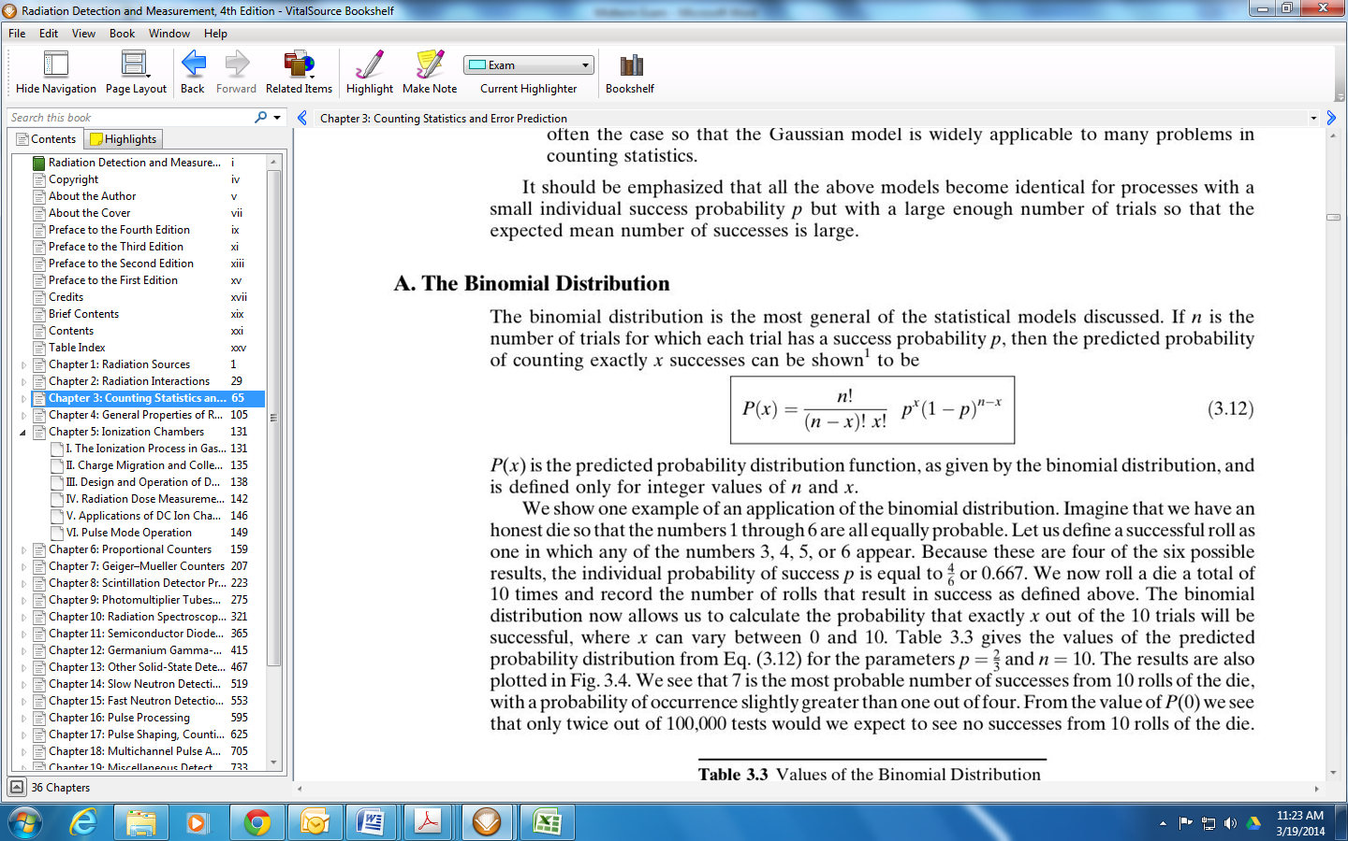
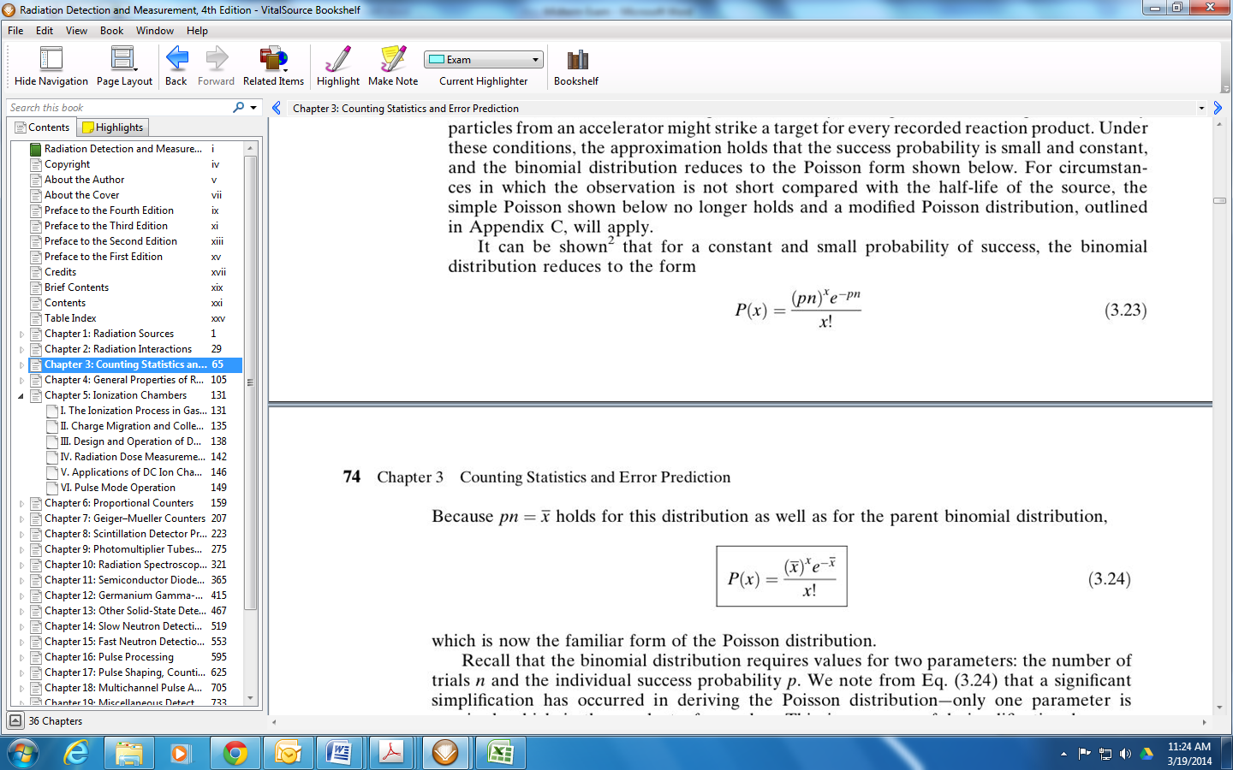

Answer all of the following questions:
Question #1 (5+5 Points):
- For each of the radiation sources listed below, indicate whether "discrete" or "continuous" is a better description:
- Conversion electrons
- Auger electrons
- Fission fragments
- Bremsstrahlung
- Annihilation radiation
Discrete: i, ii, v
Continuous: iii, iv
- Using the reaction below, find the energy released by the spontaneous fission of ²³⁵U into two equal-mass fragments.
²³⁵U ¹¹⁷Sn + ¹¹⁸Sn
Question #2 (5+5):
- Calculate the mean free path of 1 MeV gamma rays in sodium iodide (specific gravity= 3.67, and the mass attenuation coefficient is 0.06 cm²/gm).

- What fraction of 2-MeV betas will go through a single Al (density = 2.7x10³ kg/m³) foil of thickness 0.1 mm? Where; μ = 0.7714 m²/Kg

Question #3 (5+5 points):
- A 10-min count of a source+ background gives a total of 846 counts. Background alone counted for 10 min gives a total of 73 counts. What is the net counting rate due to source alone, and what is its associated standard deviation?
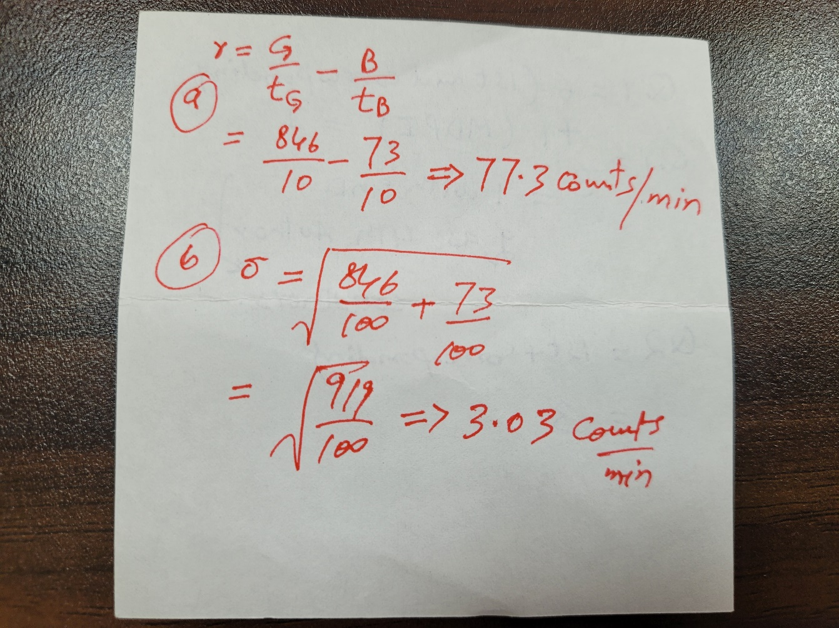

- Explain in your words the term, “Minimum Detectable Activity”.
The minimum detectable activity (MDA) is the smallest net count that can be reported with a certain degree of confidence that represents a true activity from a sample and is not a statistical variation of the background.

